Overview

L & M Machining Center Inc. is a full service machining from rapid prototype to production.

The company utilizes state of the art technology and a talented,  innovative and dedicated team to work with customer requirements, quality standards to manufacture finished products.  L & M Machining Center Inc. incorporates 3D Additive Manufacturing to expedite new product development as a gateway to our high precision machining processes. Our systems and staffing are designed to be flexible in producing low volume, high mix, batch size runs and assemblies to medium production needs to strenuous quality standards with the assistance of our multi-tasking C.N.C. machines in a Kaizen culture.  About  Founded in 1987, L & M Machining Center Inc. is a veteran-own small business (VOSB), built on a foundation of quality with extensive machining expertise. Customers range from start-ups to Fortune 500 in electronics, medical, telecom, industrial, energy, defense and aerospace industries.  Certifications – Quality Management Systems  ISO 9001 Registered  ISO 13485 Medical Devices Registered |  |  | 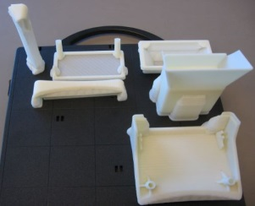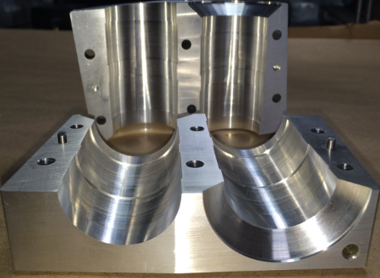
 |  |  | 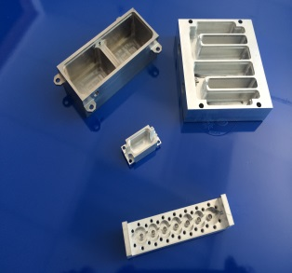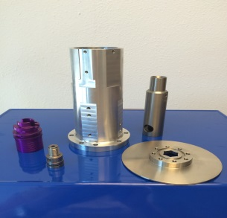
NC Programing & Machine Tools  - 5 Axis Machining  - 5 axis vertical machining centers  - 5 axis multi-tasking lathes  - 4 axis horizontal machining centers  - C.N.C. Lathes with auto loaders  - 2" through hole, 10" chucking  - C.N.C. Vertical Machining centers  - 16" x 30" work area  - Complete line of C.N.C. and conventional support equipment  Materials:  - Aluminum  - Plastic  - Stainless Steel  - Steel  - Brass  - Titanium  - High temp alloys |  | Competencies  - Prototyping  - Development (New Product or Redesigns)  - 3D Additive Manufacturing (Stratasys FDM)  - CNC Turning, Milling and Drilling  - Precision Inspection/CMM  - Batch Run production  - Short Run jobs  - Long Run jobs  Work from your Solid Models/CAD file to reduce cost and provide superior quality products  Specific Codes:  D&B: 14-303-7005  SIC Code: 3599  NAICS Code: 332710  We ship Internationally
L&M Machining Center Inc.
Our computerized management system allows us to run production 24 hours a day, five days a week.

 | “Using Quality as a Source of Economy”

